AGRICULTURE DOCS CHAIN

PROJECT REPORT

Date

Team ID

31 October 2023

NM2023TMID03779

TEAM MEMBERS :


R.VIMAL

K.Vishwa

S.Sangavi

R.pandeshwari

1

INDEX

- INTRODUCTION Project Overview Purpose

- LITERATURE SURVEY Existing problem References

Problem Statement Definition

- IDEATION & PROPOSED SOLUTION Empathy Map Canvas Ideation & Brainstorming

- REQUIREMENT ANALYSIS

Functional requirement

Non-Functional requirements

5. PROJECT DESIGN

Data Flow Diagrams & User Stories

Solution Architecture

6. PROJECT PLANNING & SCHEDULING

Technical Architecture

Sprint Planning & Estimation

Sprint Delivery Schedule

7. CODING & SOLUTIONING (Explain the features added in the project along with code)

Feature 1

Feature 2

Database Schema (if Applicable)

8. PERFORMANCE TESTING

Performace Metrics

9. RESULTS

Output Screenshots

- ADVANTAGES & DISADVANTAGES

- CONCLUSION

- FUTURE SCOPE

- APPENDIX

Source Code

GitHub & Project Demo Link

2

1.INTRODUCTION


1.1 PROJECT OVERVIEW :

The Agriculture DocsChain project aims to create a blockchain-based solution for storing and managing agricultural data. It focuses on providing a secure, transparent, and decentralized platform for farmers, agricultural organizations, and stakeholders to store, add, query, and update crucial agricultural information. This system will improve data integrity, accessibility, and trust within the agricultural sector.

Key Objectives:


Decentralized Data Storage:

The core feature of Agriculture DocsChain is a decentralized ledger that stores agricultural data in a tamper-proof and transparent manner. All participants in the network will have access to the same data, reducing the risk of data manipulation or fraud.

Data Accessibility:

Farmers, agricultural researchers, government agencies, and other stakeholders can access the data stored on the blockchain, promoting data sharing and collaboration within the agricultural community.

Data Integrity:

Data entered into the blockchain is cryptographically secured and immutable. This ensures that historical records and information remain trustworthy and cannot be altered without consensus.

User-Friendly Interface:

The platform will have a user-friendly interface for users to add, query, and update data. It should be accessible to users with varying levels of technical expertise. Smart Contracts:
Implement smart contracts for automated processes, such as crop insurance claims, supply chain tracking, and payments, to streamline operations and reduce human errors

Data Standardization:

Develop standardized data formats and protocols to ensure compatibility and consistency across the network.

Security and Privacy:

3

Implement robust security measures to protect sensitive data and provide users with control over their information.

Key Components:


Blockchain Infrastructure:

Choose an appropriate blockchain platform Ethereum for building the DocsChain. Ensure scalability and consensus mechanisms that suit the agriculture industry's needs.

Data Entry and Query Interfaces:

Create user-friendly web or mobile applications for data entry, querying, and updating. Implementing a user-friendly interface is essential for broad adoption.

Smart Contracts:

Develop smart contracts to automate processes, including data updates, payments, and validation of transactions.

Data Standardization:

Define data standards and protocols for various types of agricultural data, ensuring interoperability among different stakeholders.

Identity Management:

Implement robust identity and access management systems to protect user data and maintain privacy.

API Integration:

Enable easy integration with existing agricultural systems and data sources, ensuring a seamless flow of information into and out of the blockchain.

Consensus Mechanisms:

Determine the consensus algorithm that best fits the agricultural data use case, considering factors like transaction speed and data integrity.

Documentation and Training:

Provide comprehensive documentation and training materials for users and developers to promote adoption and development on the platform

4

1.2 PURPOSE :

The blockchain technology allows peer-to-peer transactions to take place transparently and without the need for an intermediary like a bank (such as for cryptocurrencies) or a middleman in the agriculture sector. By eliminating the need for a central authority, the technology changes the way that trust is granted – instead of trusting an authority, trust is placed in cryptography and peer-to-peer architecture. It thus helps restore the trust between producers and consumers, which can reduce the transaction costs in the agri-food market.

The blockchain technology offers a reliable approach of tracing transactions between anonymous participants. Fraud and malfunctions can thus be detected quickly. Moreover, problems can be reported in real-time by incorporating smart contract. This helps address the challenge of tracking products in the wide-reaching supply chain due to the complexity of the agri-food system. The technology thus provides solutions to issues of food quality and safety, which are highly concerned by consumers, government, etc.

The blockchain technology provides transparency among all involved parties and facilitates the collection of reliable data. Blockchain can record every step in a product’s value chain, ranging a product’s creation to its death. The reliable data of the farming process are highly valuable for developing data-driven facilities and insurance solutions for making farming smarter and less vulnerable.

Moreover we can register and update the food products easily by the owner and query to get the product details by others in this project.

5

2. LITERATURE SURVEY

2.1 EXISTING PROBLEM :

Lack of Infrastructure: In many rural areas, there is inadequate digital infrastructure, making it challenging to implement blockchain technology effectively.

Data Standardization: Agricultural data comes in various formats, making it difficult to standardize and record on a blockchain. This lack of uniformity can lead to inefficiencies.

Trust and Adoption: Farmers and other stakeholders may be hesitant to trust and adopt blockchain technology, as they might not fully understand it or have concerns about data security and ownership.

Interoperability: Different blockchains might not be compatible with each other, causing issues when multiple entities are involved in the agriculture supply chain.

Smart Contract Complexity: Creating and managing smart contracts for various agricultural processes can be complex and may require technical expertise.

Costs: Implementing and maintaining a blockchain system can be costly, and it might not be affordable for small-scale farmers or underfunded agricultural organizations.

Regulatory Challenges: Regulatory frameworks for blockchain technology in agriculture might not be well-established, causing uncertainty and potential legal issues.

Data Ownership and Privacy: Determining who owns and controls the data on the blockchain can be a contentious issue, and ensuring data privacy is a concern.

Scalability: As the volume of data and users grows, ensuring that the blockchain can scale without performance issues can be a significant problem.

Education and Training: Adequately training farmers and other stakeholders to use the blockchain system can be time-consuming and may face resistance.

6

2.2 REFERENCES :

Blockchain Technology in Current AgriculturalSystems: From Techniques to Applications Institute of Agricultural Economics and Rural Development, Guangzhou 510640, ChinaF.

Tian, ‘‘A supply chain traceability system for food safety based on

HACCP, blockchain & Internet of Things,’’ in Proc. Int. Conf. service Syst. service

Manage., 2017, pp. 1–6

- G. Zhao, S. Liu, C. Lopez, H. Lu, S. Elgueta, H. Chen, and B. M. Boshkoska, ‘‘Blockchain technology in agri-food value chain management: A synthesis of applications, challenges and
future research directions,’’ Comput. Ind., vol. 109, pp. 83–99,Aug. 2019.

    - Xiong, T. Dalhaus, P. Wang, and J. Huang, ‘‘Blockchain technology for

agriculture:

Applications and rationale,’’ Frontiers Blockchain, vol. 3, p. 7, Feb. 2020.

  - Antonucci, S. Figorilli, C. Costa, F. Pallottino, L. Raso, and P. Menesatti, ‘‘A

review on blockchain applications in the agri-food sector,’’ J. Sci. Food Agricult., vol. 99, no. 14, pp. 6129–6138,

2019

M. Lezoche, J. E. Hernandez, M. D. M. E. Alemany Díaz, H. Panetto, and J. Kacprzyk, ‘‘Agri-food 4.0: A survey of the supply chains and tech-nologies for the future agriculture,’’ Comput. Ind., vol. 117, May 2020, Art. no. 103187.

  - Sylvester, ‘‘E-agriculture in action: Blockchain for agriculture: Oppor-tunities and challenges,’’ Bangkok Int. Telecommun. Union (ITU), 2019, pp. 27–29.

7

2.3 PROBLEM STATEMENT :

In the agricultural industry, the management and verification of critical documentation, including land records, crop data, supply chain information, and certifications, are often inefficient, prone to fraud, and lack transparency.

Currently all systems rely on paper-based records, multiple intermediaries, and manual data entry, which can lead to errors, disputes, and a lack of trust within the ecosystem. Additionally, there is a growing need for secure and transparent data sharing between farmers, suppliers, regulators, and consumers.

The unique and best technology is needed to solve these problems.

8

3. IDEATION &PROPOSED SOLUTION


3.1 EMPATHY MAP CANVAS :

An empathy map is a simple, easy-to-digest visual that captures knowledge about a user’s behaviours and attitudes.

It is a useful tool to helps teams better understand their users.

Creating an effective solution requires understanding the true problem and the person who is experiencing it. The exercise of creating the map helps participants consider things from the user’s perspective along with his or her goals and challenges.

Reference: https://www.mural.co/templates/empathy-map-canvas

9

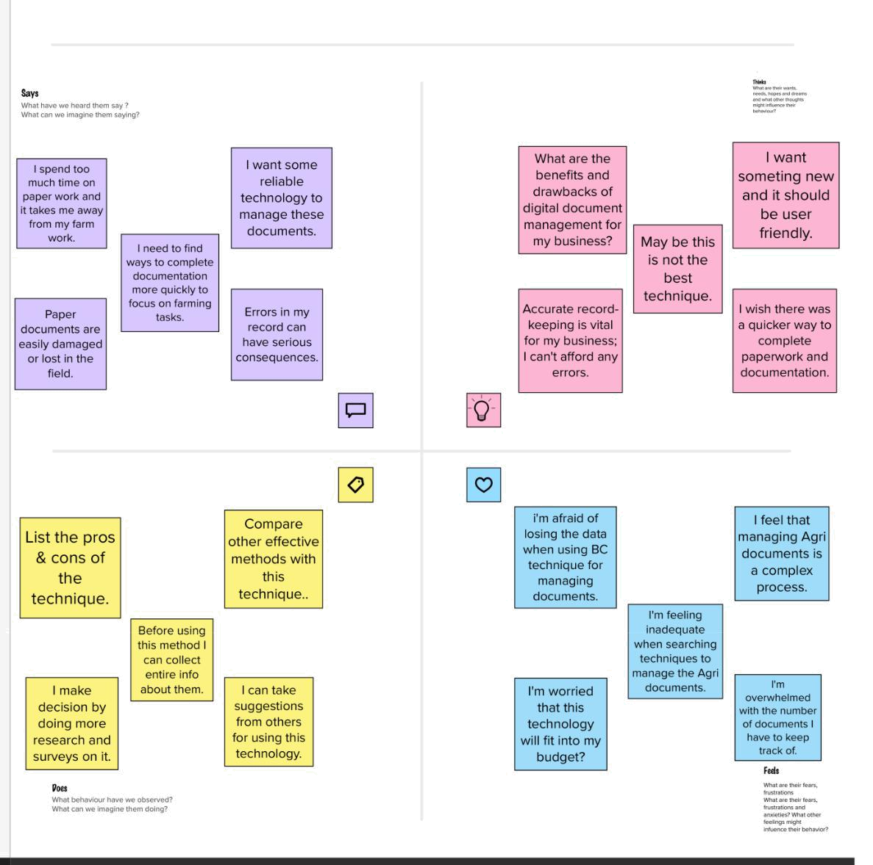

3.2 IDEATION & BRAINSTROMING :

Brainstorming provides a free and open environment that encourages everyone within a team to participate in the creative thinking process that leads to problem solving. Prioritizing volume over value, out-of-the-box ideas are welcome and built upon, and all participants are encouraged to collaborate, helping each other develop a rich amount of creative solutions.

Use this template in your own brainstorming sessions so your team can unleash their imagination and start shaping concepts even if you're not sitting in the same room.

Reference: https://www.mural.co/templates/empathy-map-canvas

10

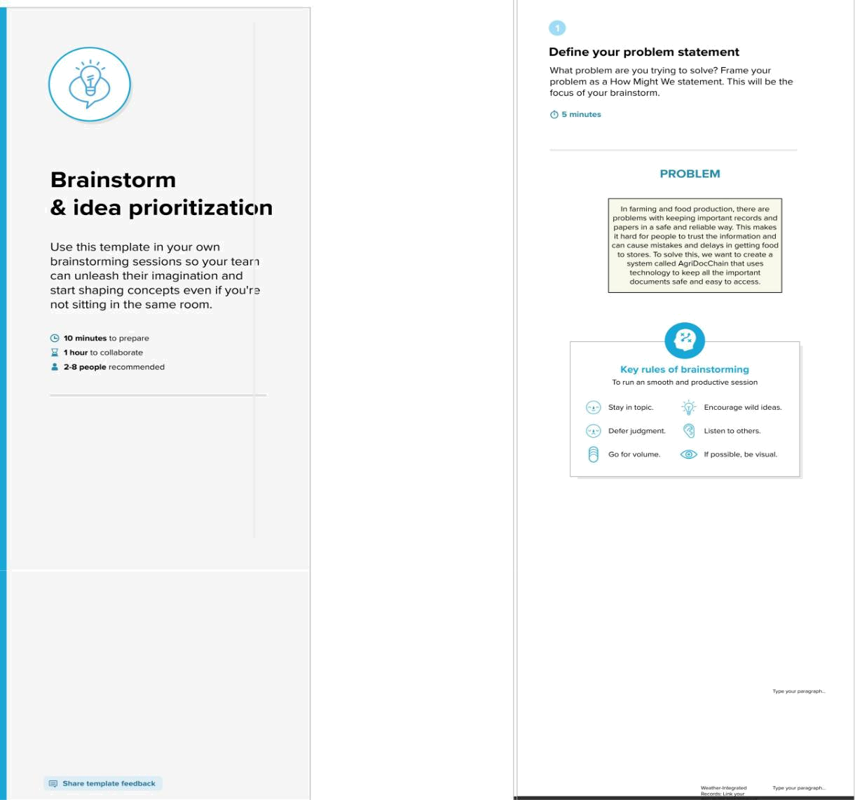

11
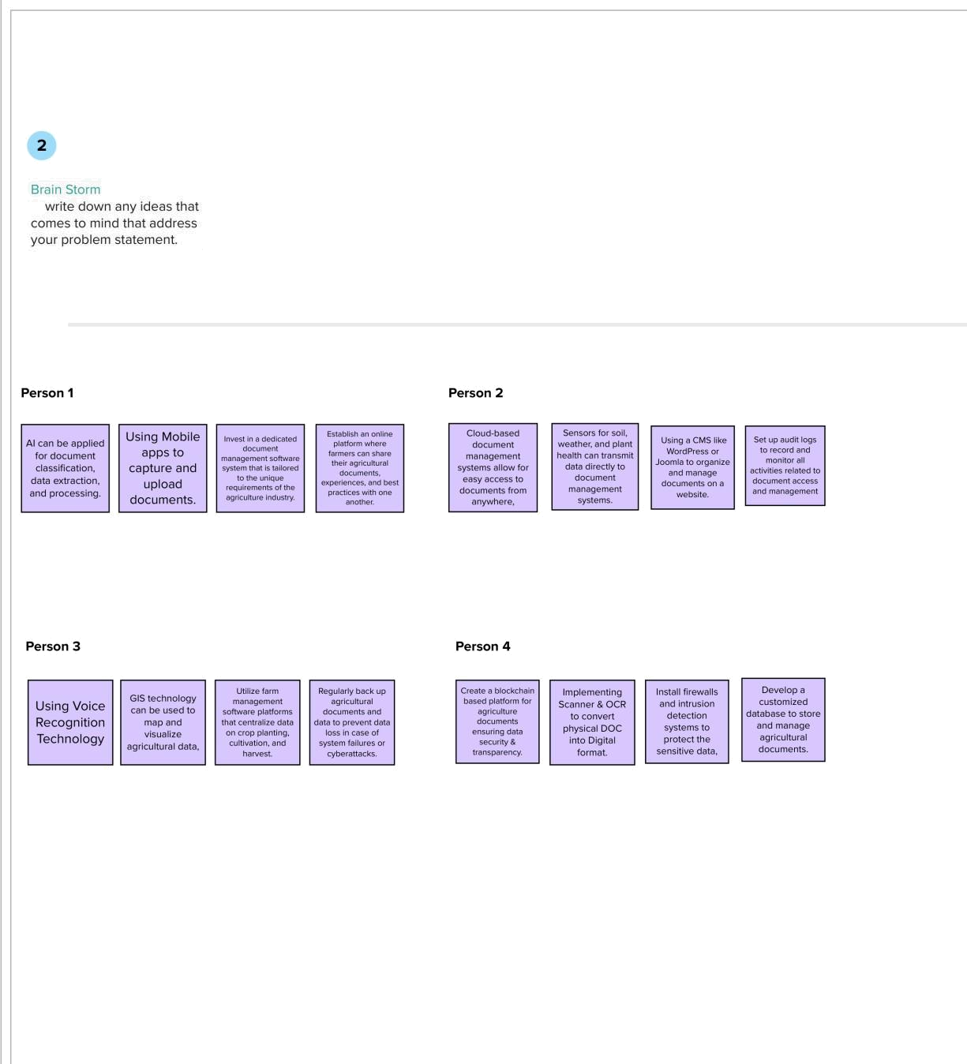

12
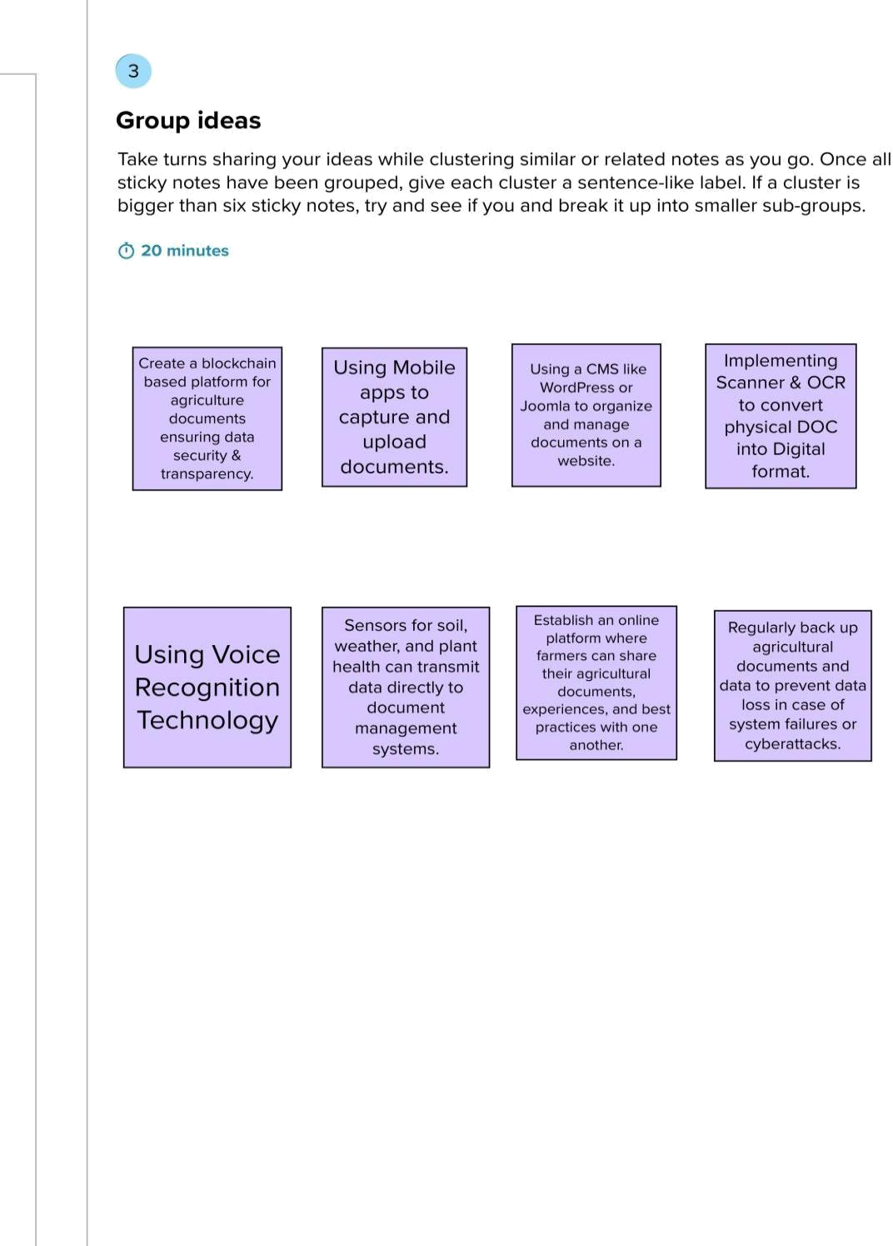

13
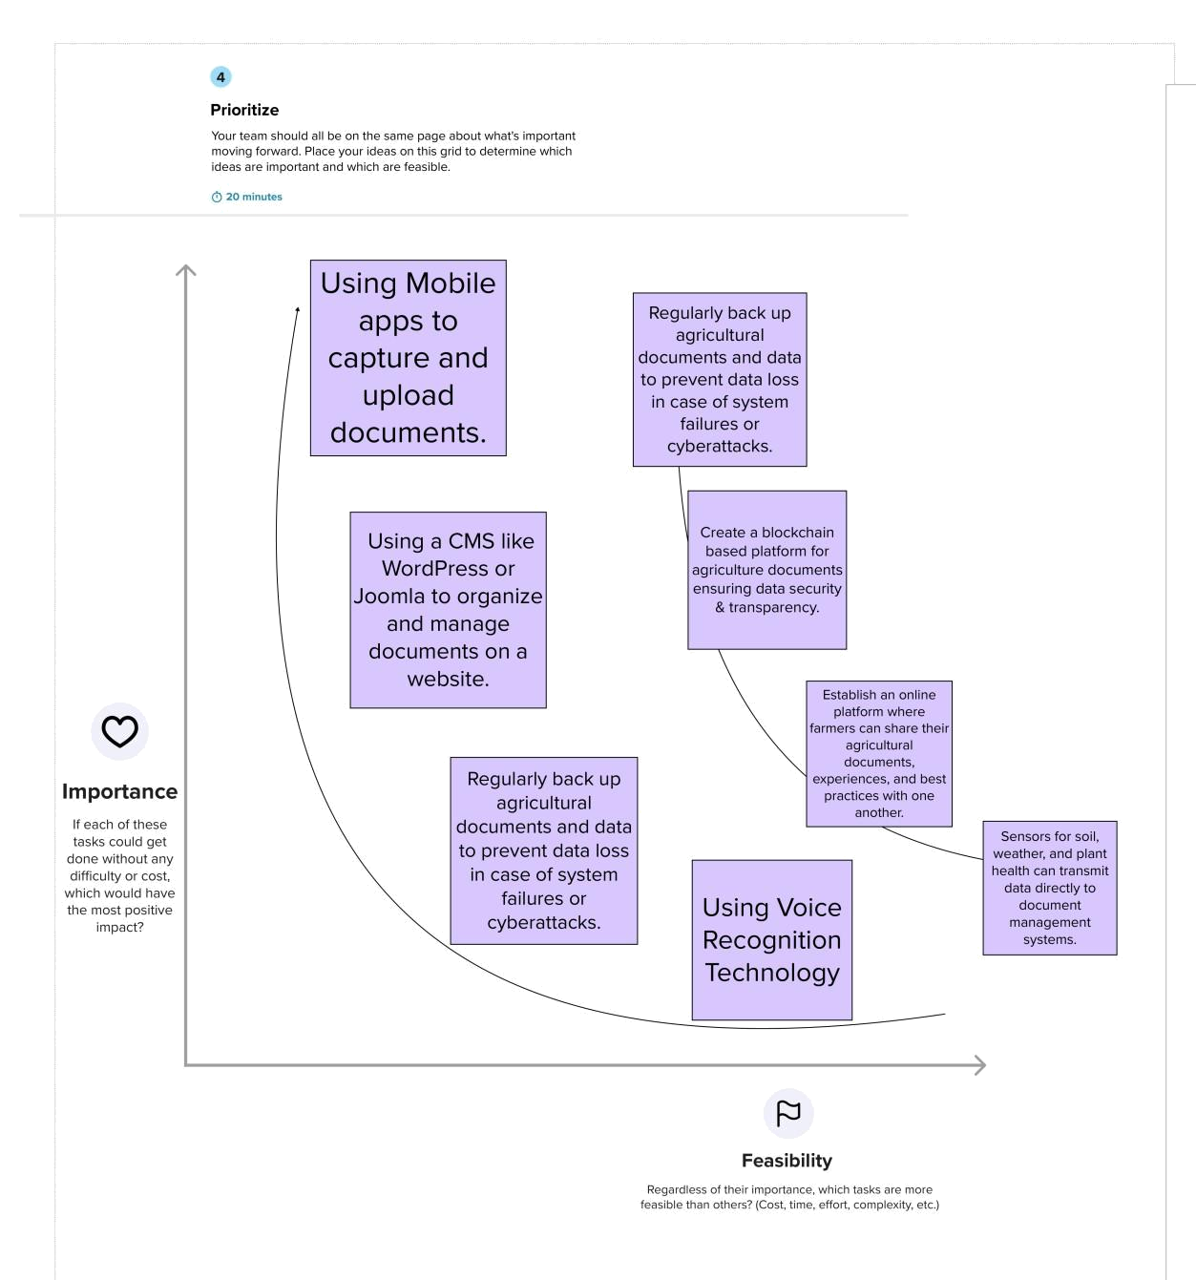

14

4. REQUIREMENT ANALYSIS

Project Design Phase-II

4.1 Functional Requirements:

Following are the functional requirements of the proposed solution.

FR | Functional |  | Requirement | Sub Requirement (Story / Sub-Task)
No. | (Epic)
FR-1 | User Registration |  |  | Users should be able to register and create
 |  |  |  | accounts.
 |  |  |  | Users should be able to log in securely.
 |  |  |  | Implement role-based access control for
 |  |  |  | different types of users (e.g., farmers,
 |  |  |  | suppliers, regulators).
FR-2 | Secure Transactions and |  |  | Facilitate secure financial transactions,
 | Payments |  |  | including payments between stakeholders.
 |  |  |  | Implement encryption and security measures
 |  |  |  | to protect sensitive financial data.
FR-3 | Notification and Alerts |  |  | Send notifications and alerts to users for
 |  |  |  | critical events, such as contract updates,
 |  |  |  | compliance violations, or supply chain
 |  |  |  | disruptions.
FR-4 | User Support |  |  | Offer customer support and resources for
 |  |  |  | users to resolve issues or answer questions.

15

4.2 Non-functional Requirements:

Following are the non-functional requirements of the proposed solution.

FR No. | Non-Functional |  | Requirement | Description
NFR-1 | Usability |  |  | Usability requirements focus on the user-
 |  |  |  | friendliness of the system.
 |  |  |  | Ensure that the system has an intuitive
 |  |  |  | and easy-to-use interface for all types of
 |  |  |  | users, including those with varying levels of
 |  |  |  | technical expertise
NFR-2 | Security |  |  | Implement strong encryption for data at
 |  |  |  | rest and data in transit.
 |  |  |  | Enforce access controls and
 |  |  |  | authentication mechanisms to prevent
 |  |  |  | unauthorized access.
NFR-3 | Reliability |  |  | Reliability requirements address the
 |  |  |  | system's ability to perform consistently and
 |  |  |  | predictably.
 |  |  |  | Ensure that the system operates without
 |  |  |  | unexpected downtime or data loss.
NFR-4 | Performance |  |  | Define the system's speed,
 |  |  |  | responsiveness, and resource utilization.
 |  |  |  | Specify acceptable response times for
 |  |  |  | various operations, such as document
 |  |  |  | retrieval, contract execution, and data
 |  |  |  | analysis.
NFR-5 | Availability |  |  | Availability requirements describe the
 |  |  |  | system's uptime and accessibility.
 |  |  |  | Set a target availability percentage (e.g.,
 |  |  |  | 99.9%) and downtime limitations.
NFR-6 | Scalability |  |  | Focus on the system's ability to handle
 |  |  |  | increased load as it grows.
 |  |  |  | Design the system architecture to be
 |  |  |  | scalable, enabling it to accommodate a
 |  |  |  | growing user base and data volume.






16

  - PROJECT DESIGN

- 1 DATA FLOW DIAGRAMS & USER STORIES:

Data Flow Diagram:

A Data Flow Diagram (DFD) is a traditional visual representation of the information flows within a system. A neat and clear DFD can depict the right amount of the system requirement graphically. It shows how data enters and leaves the system, what changes the information, and where data is stored.
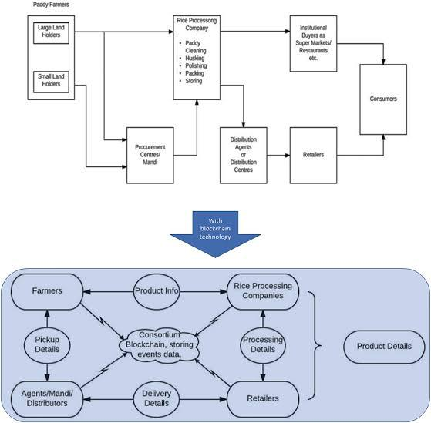

17

USER STORIES :

Use the below template to list all the user stories for the product.
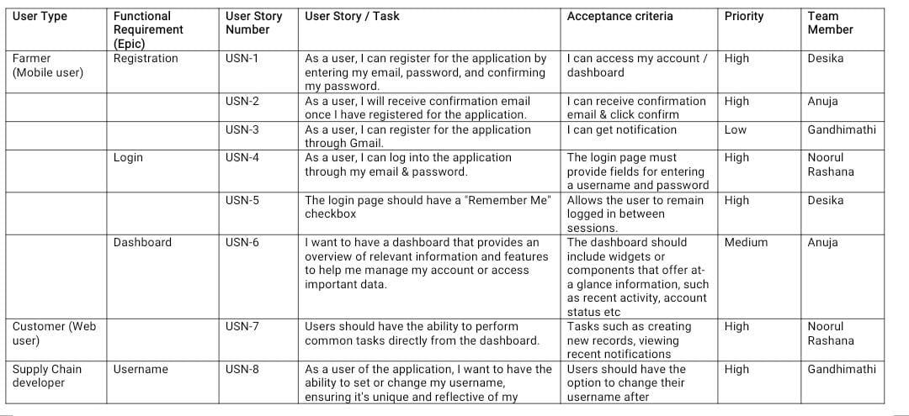

18

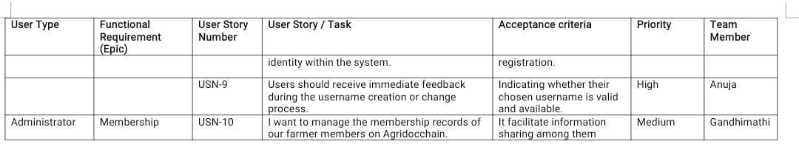

19

5. 2 SOLUTION ARCHITECHTURE:

Solution architecture is a complex process – with many sub-processes – that bridges the gap between business problems and technology solutions. Its goals are to:

- Find the best tech solution to solve existing business problems.

- Describe the structure, characteristics, behavior, and other aspects of the software to project stakeholders.

- Define features, development phases, and solution requirements.

- Provide specifications according to which the solution is defined, managed, and delivered.

Solution Architecture Diagram
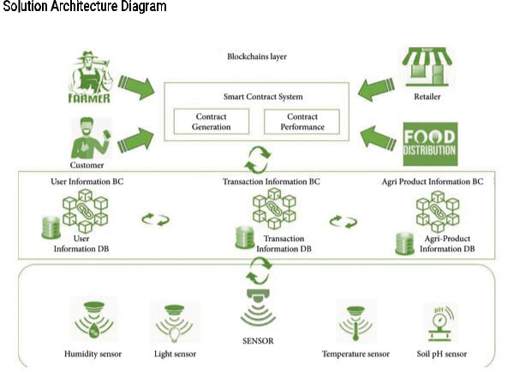

20

  - PROJECT PLANNING & SCHEDULING

- 1 TECHNICAL ARCHITECHTURE:

The Deliverable shall include the architectural diagram as below and the information as per the table1 & table 2
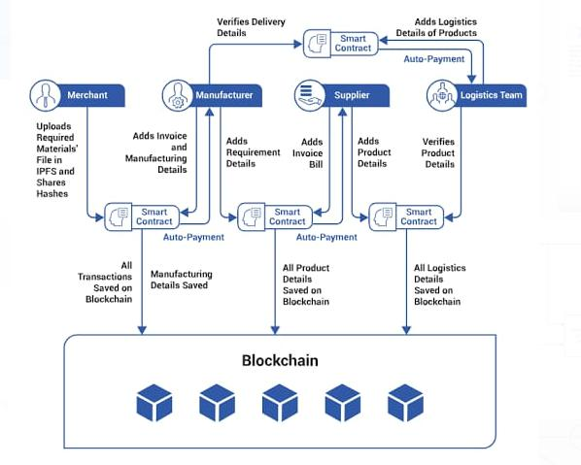

FIG: TECHNICAL ARCHITECTURE

21

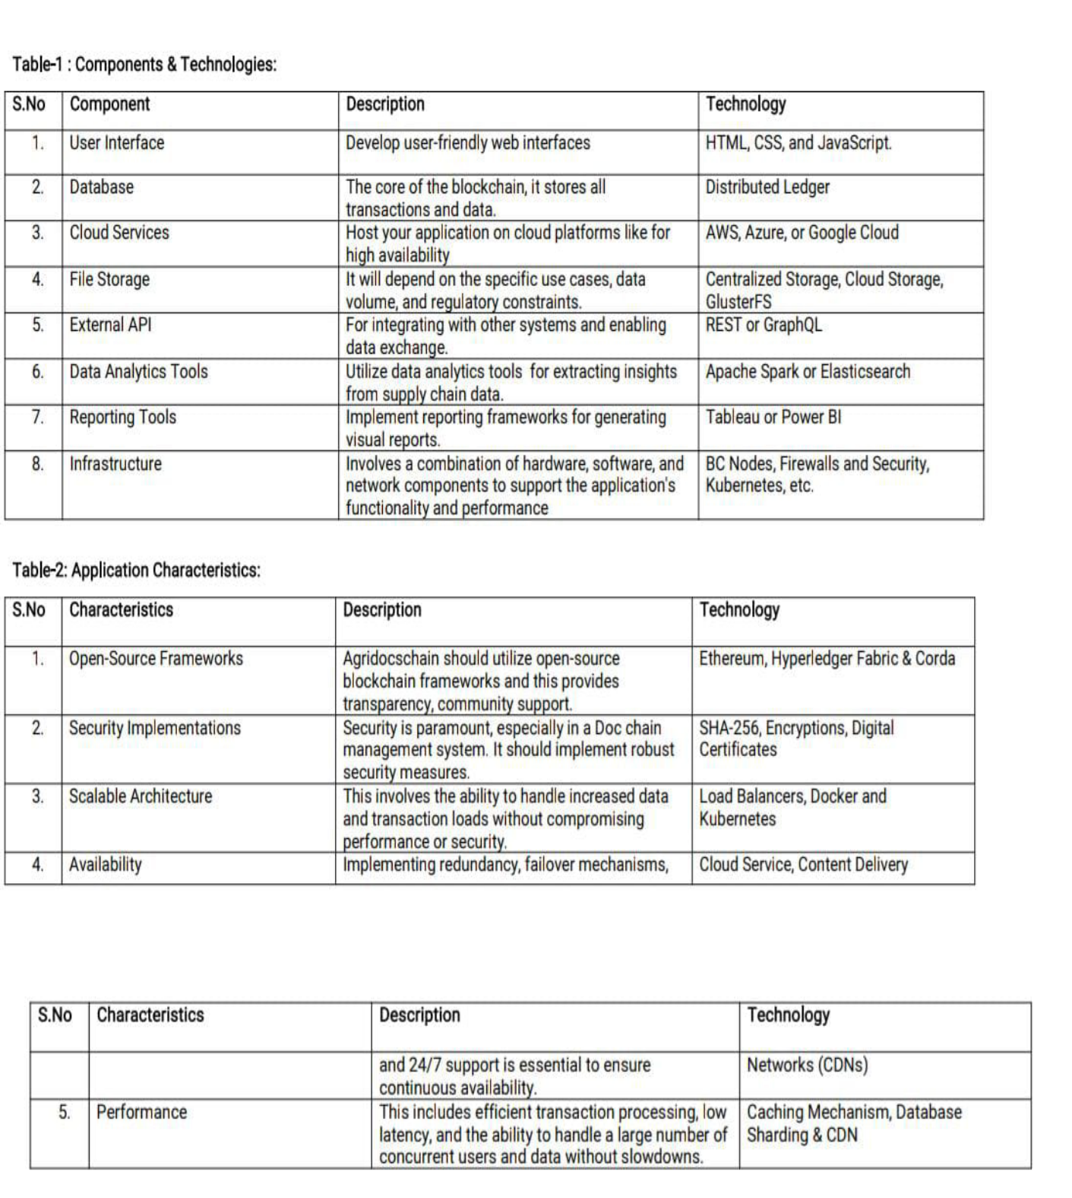

22

7. CODING AND SOLUTIONING

7.1 FEATURE 1:

Software – Remix Etherium IDE

Remix is a software application, specifically an Integrated Development Environment (IDE), designed for Ethereum smart contract development. It provides a web-based platform for Ethereum developers to write, compile, deploy, and test smart contracts, making it easier to create decentralized applications (DApps) on the Ethereum blockchain.

It provides full support for the Solidity programming language, which is commonly used for Ethereum smart contract development. Remix can compile Solidity code into Ethereum bytecode, which is essential for deploying contracts on the Ethereum blockchain.

Remix provides a testing environment for writing and running unit tests for smart contracts, helping developers ensure their code functions as expected


- SPDX-License-Identifier: MIT pragma solidity ^0.8.0;

contract AgricultureRegistry {

struct foodProduct {

string name;

string description;

uint256 quantity;

address owner;

}

mapping(uint256 => foodProduct) public products;

uint256 public productCount;

event ProductAdded(uint256 productId, string name, string description, uint256 quantity, address owner);

event ProductUpdated(uint256 productId, string name, string description, uint256 quantity);

modifier onlyOwner(uint256 _productId) {

require(products[_productId].owner == msg.sender, "Only the owner can perform this action"); _;

}

25

CSS code: (index.css)


body {

margin: 0;

font-family: -apple-system, BlinkMacSystemFont, 'Segoe UI', 'Roboto', 'Oxygen', 'Ubuntu', 'Cantarell', 'Fira Sans', 'Droid Sans', 'Helvetica Neue',

sans-serif;

-webkit-font-smoothing: antialiased;

-moz-osx-font-smoothing: grayscale;

}

code {

font-family: source-code-pro, Menlo, Monaco, Consolas, 'Courier New', monospace;

}

JAVA SCRIPTS CODE: ( connector.js )


const { ethers } = require("ethers");

const abi = [

{

"anonymous": false,

"inputs": [

{

"indexed": false,

"internalType": "uint256",

"name": "productId",

"type": "uint256"

},

{

"indexed": false,

"internalType": "string",

"name": "name",

30



"type": "string"

},

{

"indexed": false,

"internalType": "string",

"name": "description",

"type": "string"

},

{

"indexed": false,

"internalType": "uint256",

"name": "quantity",

"type": "uint256"

},

{

"indexed": false,

"internalType": "address",

"name": "owner",

"type": "address"

}

],

"name": "ProductAdded",

"type": "event"

},

{

"anonymous": false,

"inputs": [

{

"indexed": false,

"internalType": "uint256",

"name": "productId",

"type": "uint256"

},

{

"indexed": false,

"internalType": "string",

"name": "name",

"type": "string"

},

{

"indexed": false,

"internalType": "string",

"name": "description",

"type": "string"

},

{

31

"indexed": false,

"internalType": "uint256",

"name": "quantity",

"type": "uint256"

}

],

"name": "ProductUpdated",

"type": "event"

},

{

"inputs": [

{

"internalType": "uint256",

"name": "ProductId",

"type": "uint256"

},

{

"internalType": "string",

"name": "_name",

"type": "string"

},

{

"internalType": "string",

"name": "_description",

"type": "string"

},

{

"internalType": "uint256",

"name": "_quantity",

"type": "uint256"

}

],

"name": "addProduct",

"outputs": [],

"stateMutability": "nonpayable",

"type": "function"

},

{

"inputs": [

{

"internalType": "uint256",

"name": "_productId",

"type": "uint256"

}

],

"name": "getProductDetails",

32

"outputs": [

{

"internalType": "string",

"name": "name",

"type": "string"

},

{

"internalType": "string",

"name": "description",

"type": "string"

},

{

"internalType": "uint256",

"name": "quantity",

"type": "uint256"

},

{

"internalType": "address",

"name": "owner",

"type": "address"

}

],

"stateMutability": "view",

"type": "function"

},

{

"inputs": [],

"name": "productCount",

"outputs": [

{

"internalType": "uint256",

"name": "",

"type": "uint256"

}

],

"stateMutability": "view",

"type": "function"

},

{

"inputs": [

{

"internalType": "uint256",

"name": "",

"type": "uint256"

}

],

33

  - PERFORMANCE TESTING

- 1 PERFORMANCE METRICS :
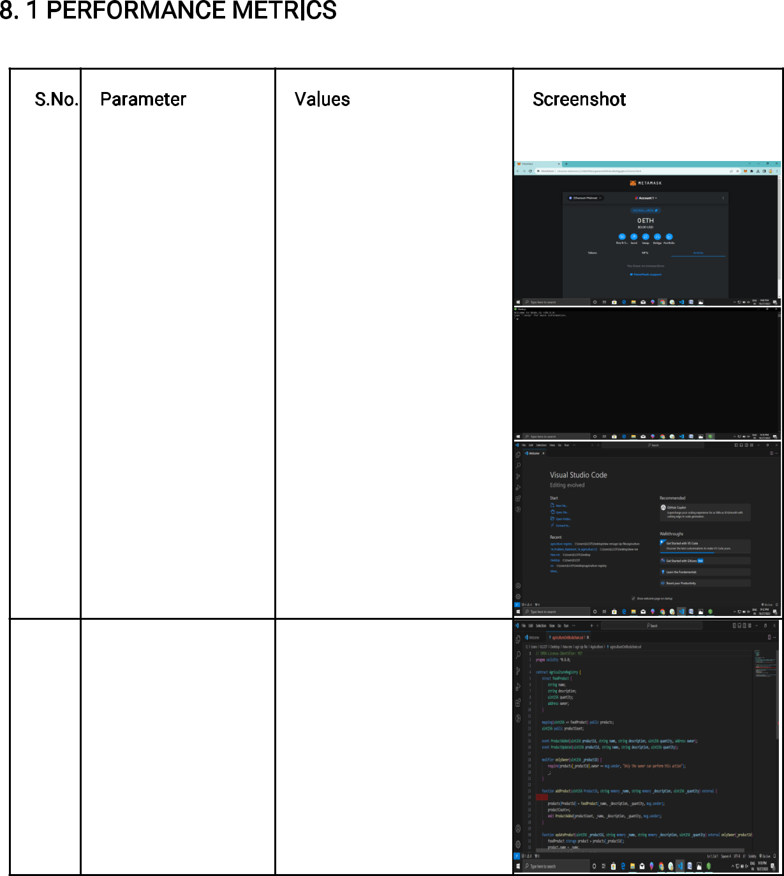

S.No. | Parameter | Values | Screenshot
1. | Information gathering | Setup all the Prerequisite:
 |  | 1.node.js
 |  | 2.vs code
 |  | 3.metamask

2.

Extract the zip files

Open to vs code

36

3.

Remix Ide platform
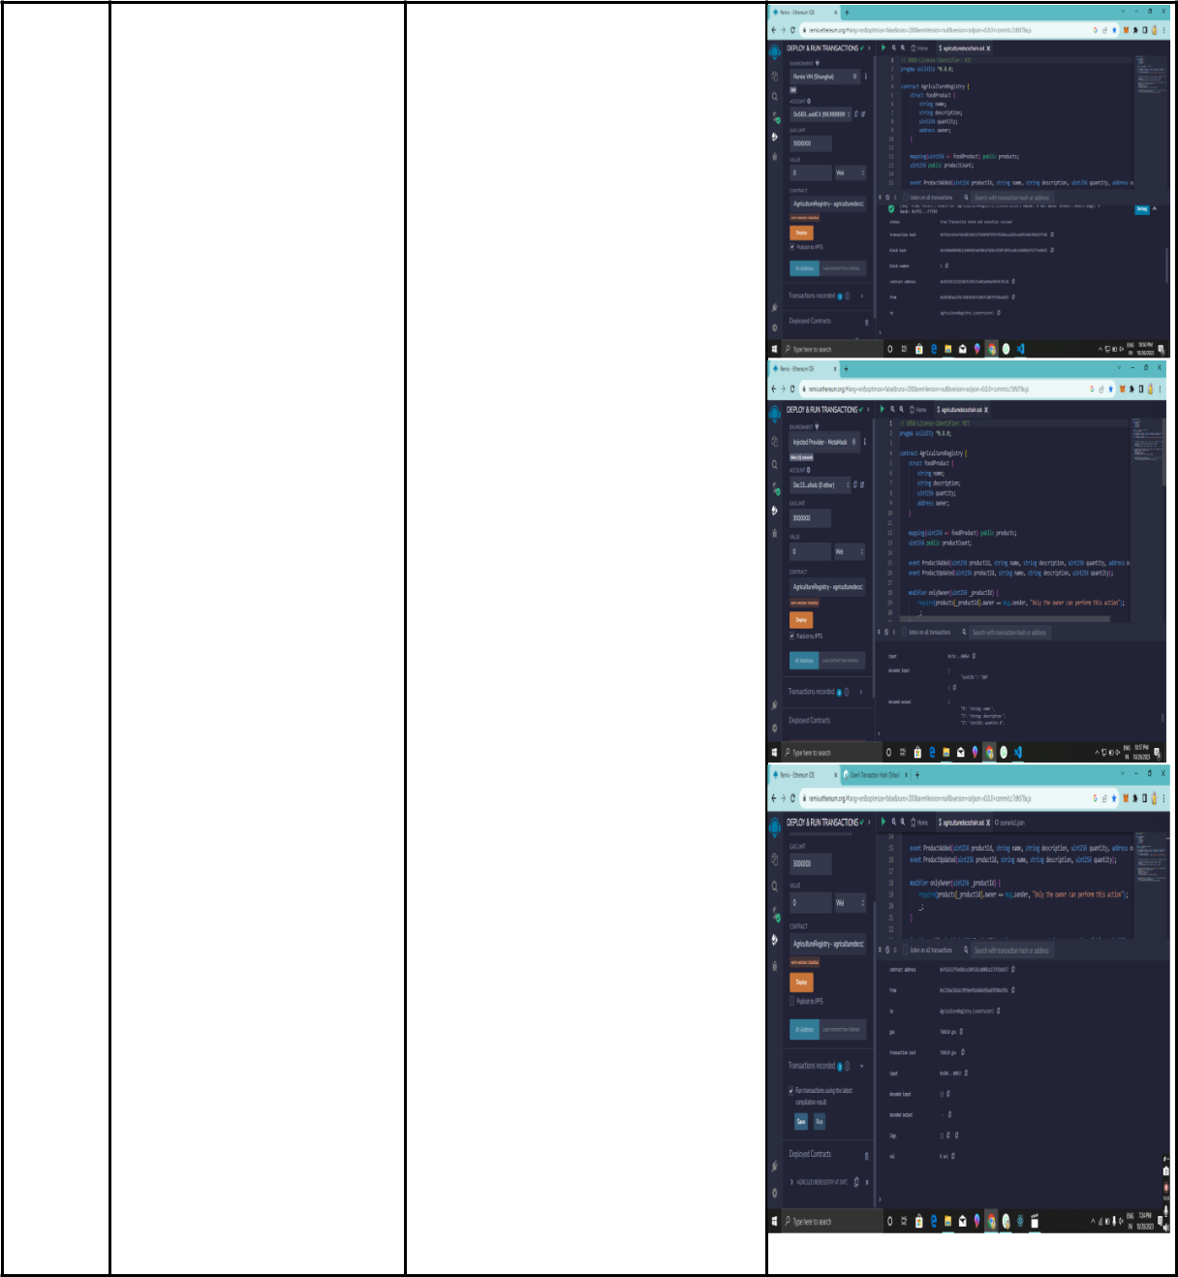
explorting
Deploy the smart contract

code

Deploy and run the

transaction. By selecting the

environment - inject the

MetaMask.

37

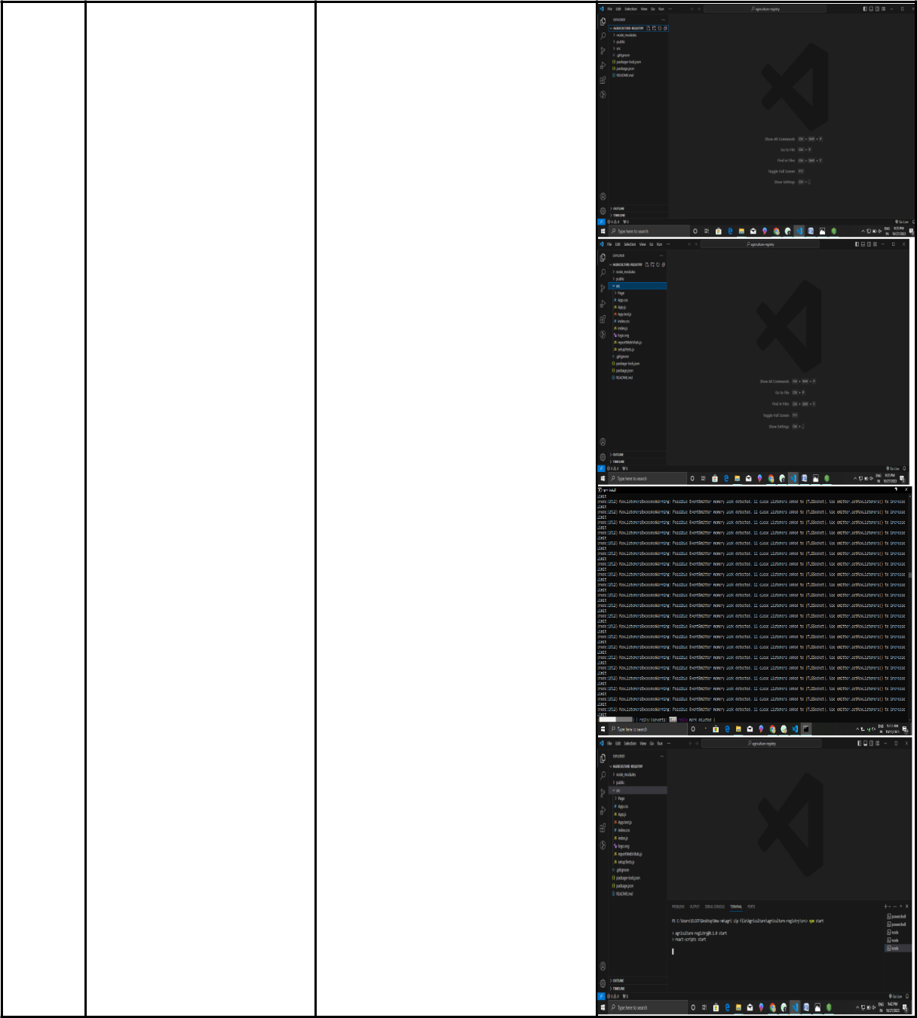

4.

Open file explorer

Open the extracted file and click on the folder.

Open src, and search for utiles.

Open cmd enter commands 1.npm install

- npm bootstrap 3.npm start

38

9. RESULTS


9.1 OUTPUT SCREENSHOTS

( Smart contract creation output)
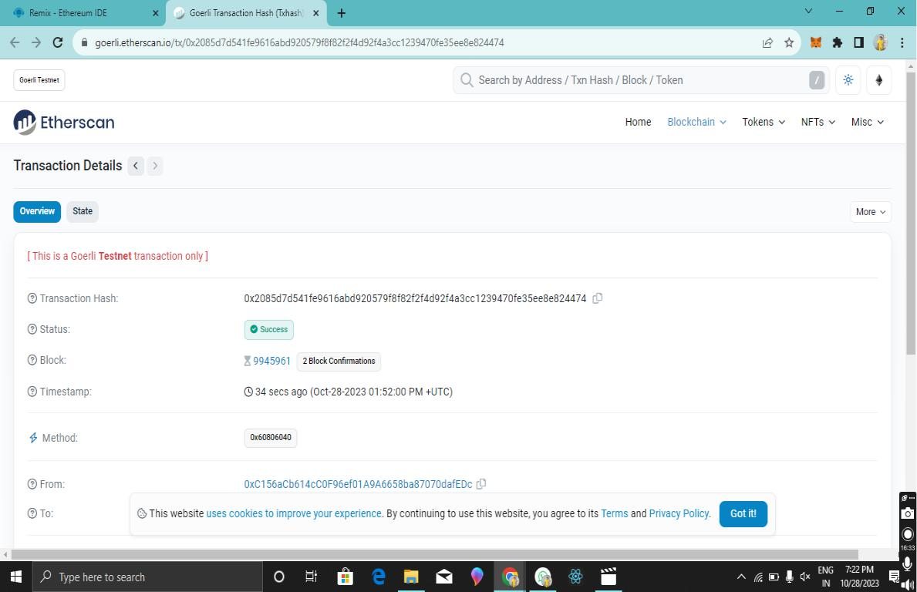

40

(Opening of local host ip address in chrome)
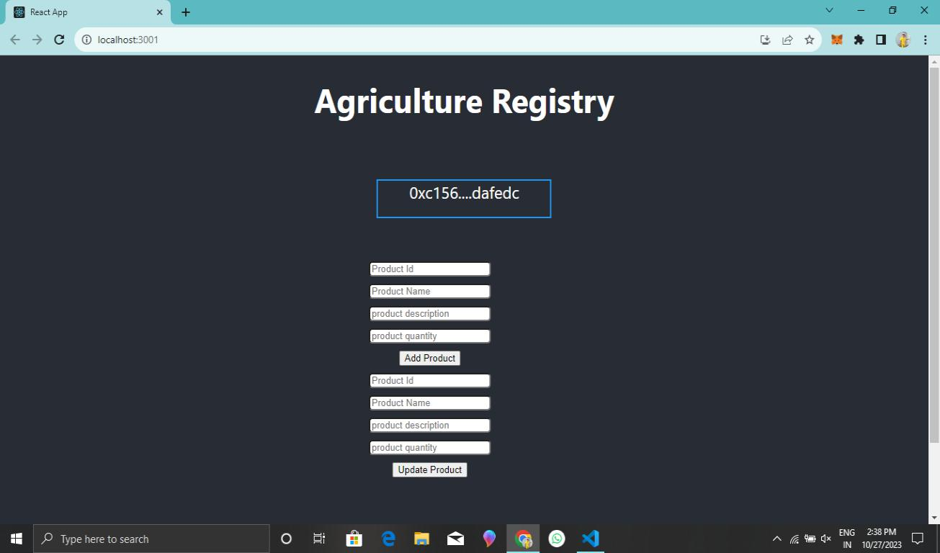

42

ADVANTAGES :

Incorporating blockchain technology into agricultural registries has the potential to revolutionize the sector by providing a more secure, efficient, and transparent way to manage and share critical agricultural data.

Data Integrity Transparency
Security among agricultural data Efficiency
Reduced intermediators Global Accessibility

DIS ADVANTAGES :

While blockchain technology offers many advantages for agriculture registries, it's essential to consider the disadvantages and challenges:

Complexity

Scalability issues

Energy Consumption Costs
Regularity Challenges Human error

47

